Useful packages for visualizations in python

Matplotlib

Matplotlib is a visualization library in Python for 2D plots of arrays. Matplotlib is written in Python and makes use of the NumPy library. It can be used in Python and IPython shells, Jupyter notebook, and web application servers. Matplotlib comes with a wide variety of plots like line, bar, scatter, histogram, etc. which can help us, deep-dive, into understanding trends, patterns, correlations. It was introduced by John Hunter in 2002.

Seaborn

Seaborn is a dataset-oriented library for making statistical representations in Python. It is developed atop matplotlib and to create different visualizations. It is integrated with pandas data structures. The library internally performs the required mapping and aggregation to create informative visuals It is recommended to use a Jupyter/IPython interface in matplotlib mode.

Bokeh

Bokeh is an interactive visualization library for modern web browsers. It is suitable for large or streaming data assets and can be used to develop interactive plots and dashboards. There is a wide array of intuitive graphs in the library which can be leveraged to develop solutions. It works closely with PyData tools. The library is well-suited for creating customized visuals according to required use-cases. The visuals can also be made interactive to serve a what-if scenario model. All the codes are open source and available on GitHub.

Altair

Altair is a declarative statistical visualization library for Python. Altair’s API is user-friendly and consistent and built atop Vega-Lite JSON specification. Declarative library indicates that while creating any visuals, we need to define the links between the data columns to the channels (x-axis, y-axis, size, color). With the help of Altair, it is possible to create informative visuals with minimal code. Altair holds a declarative grammar of both visualization and interaction.

plotly

plotly.py is an interactive, open-source, high-level, declarative, and browser-based visualization library for Python. It holds an array of useful visualization which includes scientific charts, 3D graphs, statistical charts, financial charts among others. Plotly graphs can be viewed in Jupyter notebooks, standalone HTML files, or hosted online. Plotly library provides options for interaction and editing. The robust API works perfectly in both local and web browser mode.

ggplot

ggplot is a Python implementation of the grammar of graphics. The Grammar of Graphics refers to the mapping of data to aesthetic attributes (colour, shape, size) and geometric objects (points, lines, bars). The basic building blocks according to the grammar of graphics are data, geom (geometric objects), stats (statistical transformations), scale, coordinate system, and facet.

Using ggplot in Python allows you to develop informative visualizations incrementally, understanding the nuances of the data first, and then tuning the components to improve the visual representations.

How to use the right visualization?

To extract the required information from the different visuals we create, it is quintessential that we use the correct representation based on the type of data and the questions that we are trying to understand. We will go through a set of most widely used representations below and how we can use them in the most effective manner.

Bar chart

A bar chart is used when we want to compare metric values across different subgroups of the data. If we have a greater number of groups, a bar chart is preferred over a column chart.

Bar chart using Seaborn

#Creating bar plot

sns.barplot(x = 'fare',y = 'who',data = titanic_dataset,palette = "Blues")

#Adding the aesthetics

plt.title('Chart title')

plt.xlabel('X axis title')

plt.ylabel('Y axis title')

# Show the plot

plt.show()

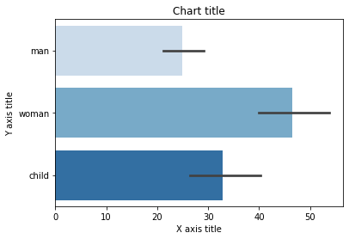

Column chart

Column charts are mostly used when we need to compare a single category of data between individual sub-items, for example, when comparing revenue between regions

Column chart using Matplotlib

#Creating the dataset

df = sns.load_dataset('titanic')

df=df.groupby('who')['fare'].sum().to_frame().reset_index()

#Creating the column plot

plt.bar(df['who'],df['fare'],color = ['#F0F8FF','#E6E6FA','#B0E0E6'])

#Adding the aesthetics

plt.title('Chart title')

plt.xlabel('X axis title')

plt.ylabel('Y axis title')

#Show the plot

plt.show()

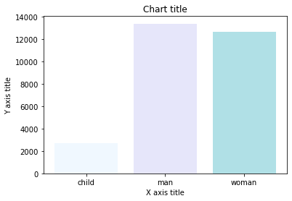

Column chart using Seaborn

#Reading the dataset

titanic_dataset = sns.load_dataset('titanic')

#Creating column chart

sns.barplot(x = 'who',y = 'fare',data = titanic_dataset,palette = "Blues")

#Adding the aesthetics

plt.title('Chart title')

plt.xlabel('X axis title')

plt.ylabel('Y axis title')

# Show the plot

plt.show()

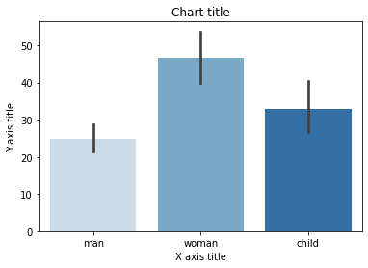

Grouped bar chart

A grouped bar chart is used when we want to compare the values in certain groups and sub-groups

Grouped bar chart using Matplotlib

#Creating the dataset

df = sns.load_dataset('titanic')

df_pivot = pd.pivot_table(df, values="fare",index="who",columns="class", aggfunc=np.mean)

#Creating a grouped bar chart

ax = df_pivot.plot(kind="bar",alpha=0.5)

#Adding the aesthetics

plt.title('Chart title')

plt.xlabel('X axis title')

plt.ylabel('Y axis title')

# Show the plot

plt.show()

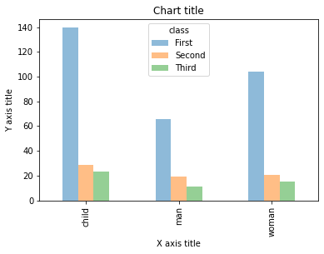

Grouped bar chart using Seaborn

#Reading the dataset

titanic_dataset = sns.load_dataset('titanic')

#Creating the bar plot grouped across classes

sns.barplot(x = 'who',y = 'fare',hue = 'class',data = titanic_dataset, palette = "Blues")

#Adding the aesthetics

plt.title('Chart title')

plt.xlabel('X axis title')

plt.ylabel('Y axis title')

# Show the plot

plt.show()

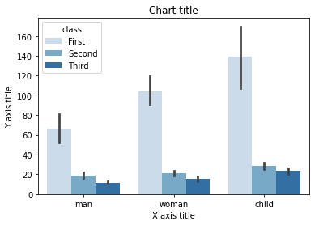

Stacked bar chart

A stacked bar chart is used when we want to compare the total sizes across the available groups and the composition of the different sub-groups

Stacked bar chart using Matplotlib

# Stacked bar chart

#Creating the dataset

df = pd.DataFrame(columns=["A","B", "C","D"],

data=[["E",0,1,1],

["F",1,1,0],

["G",0,1,0]])

df.plot.bar(x='A', y=["B", "C","D"], stacked=True, width = 0.4,alpha=0.5)

#Adding the aesthetics

plt.title('Chart title')

plt.xlabel('X axis title')

plt.ylabel('Y axis title')

#Show the plot

plt.show()

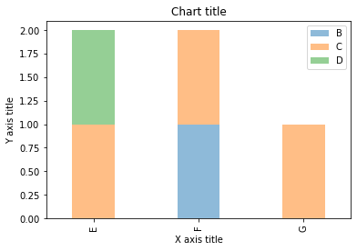

Stacked bar chart using Seaborn

dataframe = pd.DataFrame(columns=["A","B", "C","D"],

data=[["E",0,1,1],

["F",1,1,0],

["G",0,1,0]])

dataframe.set_index('A').T.plot(kind='bar', stacked=True)

#Adding the aesthetics

plt.title('Chart title')

plt.xlabel('X axis title')

plt.ylabel('Y axis title')

# Show the plot

plt.show()

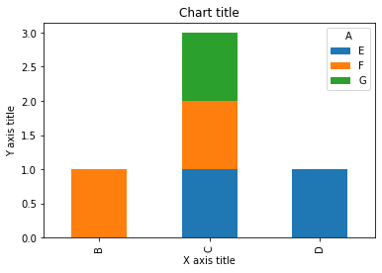

Line chart

A line chart is used for the representation of continuous data points. This visual can be effectively utilized when we want to understand the trend across time.

Line chart using Matplotlib

#Creating the dataset

df = sns.load_dataset("iris")

df=df.groupby('sepal_length')['sepal_width'].sum().to_frame().reset_index()

#Creating the line chart

plt.plot(df['sepal_length'], df['sepal_width'])

#Adding the aesthetics

plt.title('Chart title')

plt.xlabel('X axis title')

plt.ylabel('Y axis title')

#Show the plot

plt.show()

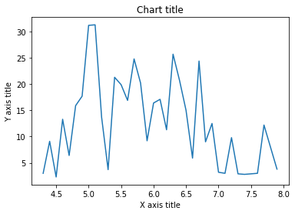

Line chart using Seaborn

#Creating the dataset

cars = ['AUDI', 'BMW', 'NISSAN',

'TESLA', 'HYUNDAI', 'HONDA']

data = [20, 15, 15, 14, 16, 20]

#Creating the pie chart

plt.pie(data, labels = cars,colors = ['#F0F8FF','#E6E6FA','#B0E0E6','#7B68EE','#483D8B'])

#Adding the aesthetics

plt.title('Chart title')

#Show the plot

plt.show()

Pie chart

Pie charts can be used to identify proportions of the different components in a given whole.

Pie chart using Matplotlib

#Creating the dataset

cars = ['AUDI', 'BMW', 'NISSAN',

'TESLA', 'HYUNDAI', 'HONDA']

data = [20, 15, 15, 14, 16, 20]

#Creating the pie chart

plt.pie(data, labels = cars,colors = ['#F0F8FF','#E6E6FA','#B0E0E6','#7B68EE','#483D8B'])

#Adding the aesthetics

plt.title('Chart title')

#Show the plot

plt.show()

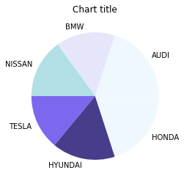

Area chart

Area charts are used to track changes over time for one or more groups. Area graphs are preferred over line charts when we want to capture the changes over time for more than 1 group.

Area chart using Matplotlib

#Reading the dataset

x=range(1,6)

y=[ [1,4,6,8,9], [2,2,7,10,12], [2,8,5,10,6] ]

#Creating the area chart

ax = plt.gca()

ax.stackplot(x, y, labels=['A','B','C'],alpha=0.5)

#Adding the aesthetics

plt.legend(loc='upper left')

plt.title('Chart title')

plt.xlabel('X axis title')

plt.ylabel('Y axis title')

#Show the plot

plt.show()

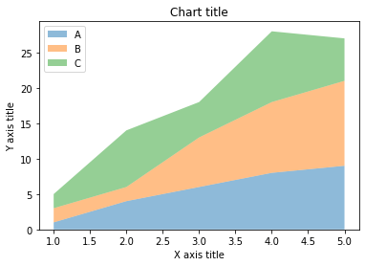

Area chart using Seaborn

# Data

years_of_experience =[1,2,3]

salary=[ [6,8,10], [4,5,9], [3,5,7] ]

# Plot

plt.stackplot(years_of_experience,salary, labels=['Company A','Company B','Company C'])

plt.legend(loc='upper left')

#Adding the aesthetics

plt.title('Chart title')

plt.xlabel('X axis title')

plt.ylabel('Y axis title')

# Show the plot

plt.show()

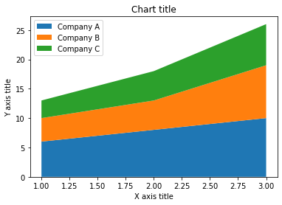

Column histogram

Column histograms are used to observe the distribution for a single variable with few data points.

Column chart using Matplotlib

#Creating the dataset

penguins = sns.load_dataset("penguins")

#Creating the column histogram

ax = plt.gca()

ax.hist(penguins['flipper_length_mm'], color='blue',alpha=0.5, bins=10)

#Adding the aesthetics

plt.title('Chart title')

plt.xlabel('X axis title')

plt.ylabel('Y axis title')

#Show the plot

plt.show()

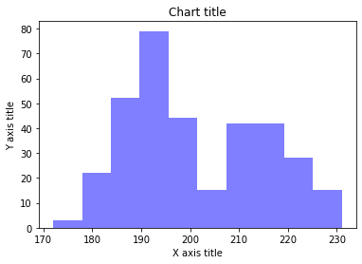

Column chart using Seaborn

#Reading the dataset

penguins_dataframe = sns.load_dataset("penguins")

#Plotting bar histogram

sns.distplot(penguins_dataframe['flipper_length_mm'], kde=False, color='blue', bins=10)

#Adding the aesthetics

plt.title('Chart title')

plt.xlabel('X axis title')

plt.ylabel('Y axis title')

# Show the plot

plt.show()

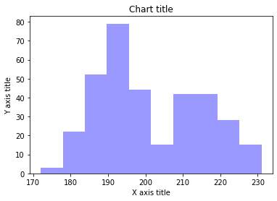

Line histogram

Line histograms are used to observe the distribution for a single variable with many data points.

Line histogram chart using Matplotlib

#Creating the dataset

df_1 = np.random.normal(0, 1, (1000, ))

density = stats.gaussian_kde(df_1)

#Creating the line histogram

n, x, _ = plt.hist(df_1, bins=np.linspace(-3, 3, 50), histtype=u'step', density=True)

plt.plot(x, density(x))

#Adding the aesthetics

plt.title('Chart title')

plt.xlabel('X axis title')

plt.ylabel('Y axis title')

#Show the plot

plt.show()

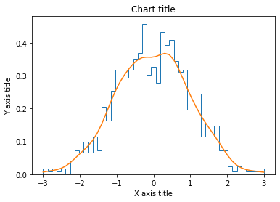

Line histogram chart using Seaborn

#Reading the dataset

penguins_dataframe = sns.load_dataset("penguins")

#Plotting line histogram

sns.distplot(penguins_dataframe['flipper_length_mm'], hist = False, kde = True, label='Africa')

#Adding the aesthetics

plt.title('Chart title')

plt.xlabel('X axis title')

plt.ylabel('Y axis title')

# Show the plot

plt.show()

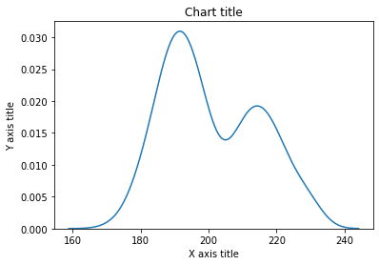

Scatter plot

Scatter plots can be leveraged to identify relationships between two variables. It can be effectively used in circumstances where the dependent variable can have multiple values for the independent variable.

Scatter plot using Matplotlib

#Creating the dataset

df = sns.load_dataset("tips")

#Creating the scatter plot

plt.scatter(df['total_bill'],df['tip'],alpha=0.5 )

#Adding the aesthetics

plt.title('Chart title')

plt.xlabel('X axis title')

plt.ylabel('Y axis title')

#Show the plot

plt.show()

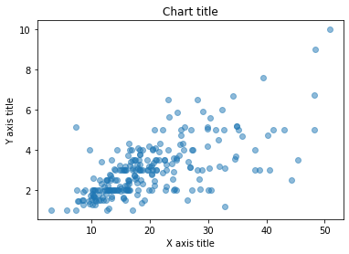

Scatter plot using Seaborn

#Reading the dataset

bill_dataframe = sns.load_dataset("tips")

#Creating scatter plot

sns.scatterplot(data=bill_dataframe, x="total_bill", y="tip")

#Adding the aesthetics

plt.title('Chart title')

plt.xlabel('X axis title')

plt.ylabel('Y axis title')

# Show the plot

plt.show()

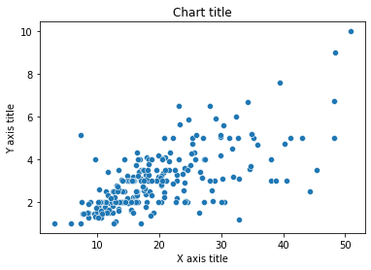

Bubble chart

Scatter plots can be leveraged to depict and show relationships among three variables.

Bubble chart using Matplotlib

#Creating the dataset

np.random.seed(42)

N = 100

x = np.random.normal(170, 20, N)

y = x + np.random.normal(5, 25, N)

colors = np.random.rand(N)

area = (25 * np.random.rand(N))**2

df = pd.DataFrame({

'X': x,

'Y': y,

'Colors': colors,

"bubble_size":area})

#Creating the bubble chart

plt.scatter('X', 'Y', s='bubble_size',alpha=0.5, data=df)

#Adding the aesthetics

plt.title('Chart title')

plt.xlabel('X axis title')

plt.ylabel('Y axis title')

#Show the plot

plt.show()

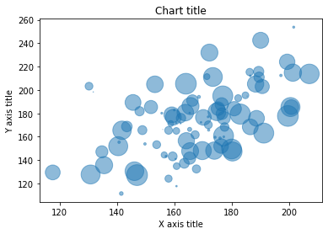

Bubble chart using Seaborn

#Reading the dataset

bill_dataframe = sns.load_dataset("tips")

#Creating bubble plot

sns.scatterplot(data=bill_dataframe, x="total_bill", y="tip", hue="size", size="size")

#Adding the aesthetics

plt.title('Chart title')

plt.xlabel('X axis title')

plt.ylabel('Y axis title')

# Show the plot

plt.show()

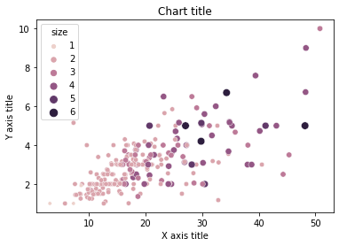

Box plot

A box plot is used to show the shape of the distribution, its central value, and its variability.

Box plot using Matplotlib

from past.builtins import xrange

#Creating the dataset

df_1 = [[1,2,5], [5,7,2,2,5], [7,2,5]]

df_2 = [[6,4,2], [1,2,5,3,2], [2,3,5,1]]

#Creating the box plot

ticks = ['A', 'B', 'C']

plt.figure()

bpl = plt.boxplot(df_1, positions=np.array(xrange(len(df_1)))*2.0-0.4, sym='', widths=0.6)

bpr = plt.boxplot(df_2, positions=np.array(xrange(len(df_2)))*2.0+0.4, sym='', widths=0.6)

plt.plot([], c='#D7191C', label='Label 1')

plt.plot([], c='#2C7BB6', label='Label 2')

#Adding the aesthetics

plt.title('Chart title')

plt.xlabel('X axis title')

plt.ylabel('Y axis title')

plt.legend()

plt.xticks(xrange(0, len(ticks) * 2, 2), ticks)

plt.xlim(-2, len(ticks)*2)

plt.ylim(0, 8)

plt.tight_layout()

#Show the plot

plt.show()

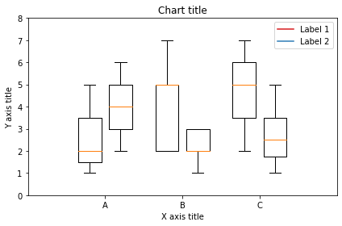

Box plot using Seaborn

#Reading the dataset

bill_dataframe = sns.load_dataset("tips")

#Creating boxplots

ax = sns.boxplot(x="day", y="total_bill", hue="smoker", data=bill_dataframe, palette="Set3")

#Adding the aesthetics

plt.title('Chart title')

plt.xlabel('X axis title')

plt.ylabel('Y axis title')

# Show the plot

plt.show()

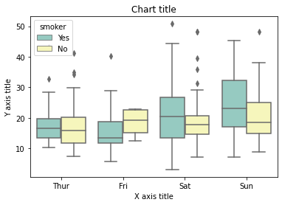

Waterfall chart

A waterfall chart can be used to explain the gradual transition in value of a variable that is subjected to increments or decrements

#Reading the dataset

test = pd.Series(-1 + 2 * np.random.rand(10), index=list('abcdefghij'))

#Function for makig a waterfall chart

def waterfall(series):

df = pd.DataFrame({'pos':np.maximum(series,0),'neg':np.minimum(series,0)})

blank = series.cumsum().shift(1).fillna(0)

df.plot(kind='bar', stacked=True, bottom=blank, color=['r','b'], alpha=0.5)

step = blank.reset_index(drop=True).repeat(3).shift(-1)

step[1::3] = np.nan

plt.plot(step.index, step.values,'k')

#Creating the waterfall chart

waterfall(test)

#Adding the aesthetics

plt.title('Chart title')

plt.xlabel('X axis title')

plt.ylabel('Y axis title')

#Show the plot

plt.show()

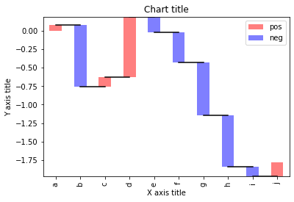

Venn diagram

Venn diagrams are used to see the relationships between two or three sets of items. It highlights the similarities and differences

from matplotlib_venn import venn3

#Making venn diagram

venn3(subsets = (10, 8, 22, 6,9,4,2))

plt.show()

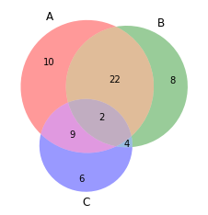

Tree map

Tree Maps are primarily used to display data that is grouped and nested in a hierarchical structure and observe the contribution of each component

import squarify

sizes = [40, 30, 5, 25, 10]

squarify.plot(sizes)

#Adding the aesthetics

plt.title('Chart title')

plt.xlabel('X axis title')

plt.ylabel('Y axis title')

# Show the plot

plt.show()

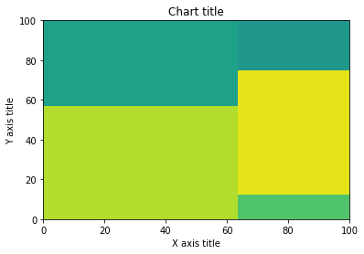

100% stacked bar chart

A 100% stacked bar chart can be leveraged when we want to show the relative differences within each group for the different sub-groups available

#Reading the dataset

r = [0,1,2,3,4]

raw_data = {'greenBars': [20, 1.5, 7, 10, 5], 'orangeBars': [5, 15, 5, 10, 15],'blueBars': [2, 15, 18, 5, 10]}

df = pd.DataFrame(raw_data)

# From raw value to percentage

totals = [i+j+k for i,j,k in zip(df['greenBars'], df['orangeBars'], df['blueBars'])]

greenBars = [i / j * 100 for i,j in zip(df['greenBars'], totals)]

orangeBars = [i / j * 100 for i,j in zip(df['orangeBars'], totals)]

blueBars = [i / j * 100 for i,j in zip(df['blueBars'], totals)]

# plot

barWidth = 0.85

names = ('A','B','C','D','E')

# Create green Bars

plt.bar(r, greenBars, color='#b5ffb9', edgecolor='white', width=barWidth)

# Create orange Bars

plt.bar(r, orangeBars, bottom=greenBars, color='#f9bc86', edgecolor='white', width=barWidth)

# Create blue Bars

plt.bar(r, blueBars, bottom=[i+j for i,j in zip(greenBars, orangeBars)], color='#a3acff', edgecolor='white', width=barWidth)

# Custom x axis

plt.xticks(r, names)

plt.xlabel("group")

#Adding the aesthetics

plt.title('Chart title')

plt.xlabel('X axis title')

plt.ylabel('Y axis title')

plt.show()

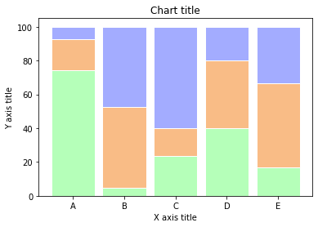

Marginal plots

Marginal plots are used to assess the relationship between two variables and examine their distributions. Such plots scatter plots that have histograms, box plots, or dot plots in the margins of respective x and y axes

#Reading the dataset

iris_dataframe = sns.load_dataset('iris')

#Creating marginal graphs

sns.jointplot(x=iris_dataframe["sepal_length"], y=iris_dataframe["sepal_width"], kind='scatter')

# Show the plot

plt.show()

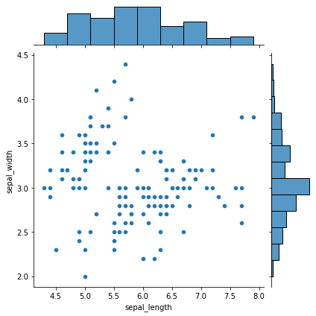

Subplots

Subplots are powerful visualizations that help easy comparisons between plots

#Creating the dataset

df = sns.load_dataset("iris")

df=df.groupby('sepal_length')['sepal_width'].sum().to_frame().reset_index()

#Creating the subplot

fig, axes = plt.subplots(nrows=2, ncols=2)

ax=df.plot('sepal_length', 'sepal_width',ax=axes[0,0])

ax.get_legend().remove()

#Adding the aesthetics

ax.set_title('Chart title')

ax.set_xlabel('X axis title')

ax.set_ylabel('Y axis title')

ax=df.plot('sepal_length', 'sepal_width',ax=axes[0,1])

ax.get_legend().remove()

ax=df.plot('sepal_length', 'sepal_width',ax=axes[1,0])

ax.get_legend().remove()

ax=df.plot('sepal_length', 'sepal_width',ax=axes[1,1])

ax.get_legend().remove()

#Show the plot

plt.show()

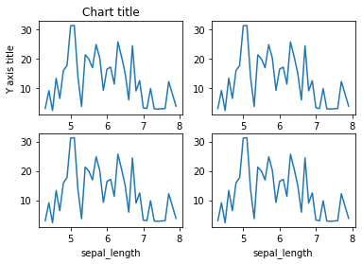

In conclusion, there is an array of different libraries which can be leveraged to their full potential by understanding the use-case and the requirement. The syntax and the semantics vary from package to package and it is essential to understand the challenges and advantages of the different libraries. Happy visualizing!